INTERMARK WINS 2022 CORE VALUE AWARD FOR AGILITY
PRESENTED BY STERLING LEXICON

15/09/2022
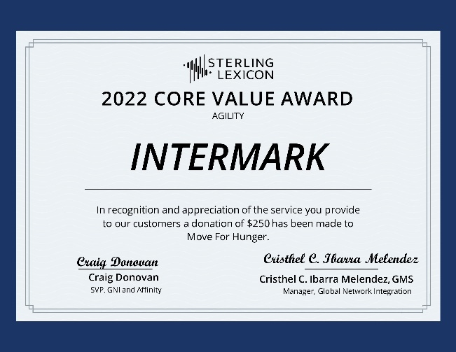

Intermark, a leading provider of immigration, relocation and moving services, was recently honored to receive the 2022 Core Value Award for Agility from Sterling Lexicon in recognition and appreciation of outstanding service and solving unique customer and employee challenges while readily adapting to changing market needs.

“We are grateful for such esteemed recognition from our friends and partners at Sterling Lexicon. Our company values are aligned on the importance of building our trusted collaboration and innovating solutions to make our ever-changing world a better place. We look forward to continued success together with our professional and dedicated team”, said Irina Yakimenko, Intermark Managing Partner.

“Your bravery and dedication to support your clients, partners and teams through such difficult times are admirable and worthy of recognition”, said Craig Donovan, Senior Vice President of Sterling Lexicon.

Sterling Lexicon is a leading provider of relocation services, which offers companies end-to-end relocation solutions that enhance the mobility experience, delivering employees at destination. It annually brings together global mobility industry professionals to recognize their contribution in the market. Core Value awards are also presented for care, trust, and teamwork.

Intermark is a relocation consultancy established in 1993. The company provides a full range of immigration, relocation, household goods moving services to major international companies worldwide, including Azerbaijan, Belarus, Georgia, Kazakhstan, Russia, Ukraine and other countries. During the existence of Intermark, it has accumulated invaluable expertise and comprehensive services to allow clients to smoothly and easily adapt to a new environment, a new reality and a new life on assignment. Intermark uses technologies and innovations to maintain leadership in a changing industry to offer a seamless relocation, immigration and moving experience to customers.

Contact:
Anna Vaganova
PR Specialist
+7 (967) 212 95 02
A.Vaganova@intermarkrelocation.com

