Brother’s latest color laser series is flexible and efficient to help businesses thrive

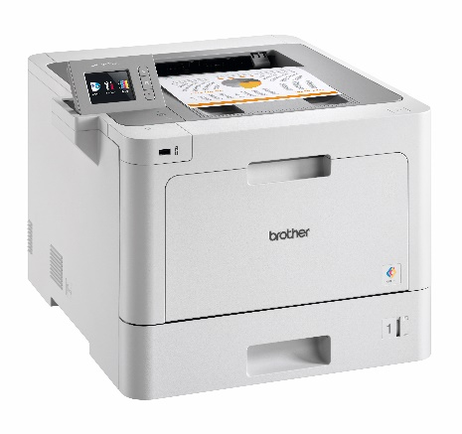
Brother has launched its new color laser range - a true technology partner for businesses - boasting flexibility, reliability, security and high quality printing at a competitive cost per page.

The print specialist’s new range has been designed to improve the productivity and efficiency of high volume workgroups and growing businesses.

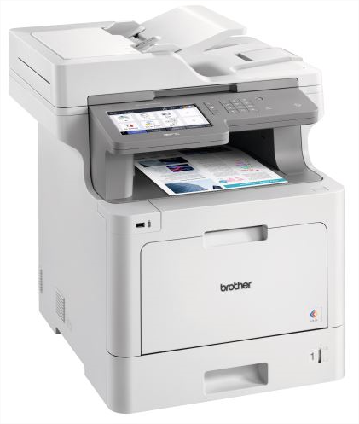
The line-up features five models, including two printers (HL-L8260CDW, HL-L9310CDW) and three MFPs (DCP-L8410CDW, MFC-L8690CDW, MFC-L9570CDW). Flagship models offer advanced paper handling options with expandable paper trays enabling your printer to grow alongside your business.
HL-L9310CDW

The series is packed with speed, with up to 31 pages per minute color and mono printing across the series. The range also features a Brother first, with 100 ipm mono and color scanning on flagship MFP.

Designed as a smarter way to work, the range has an Automatic Document Feeder holding up to 80 sheets, providing a quick and simple way to scan direct to the cloud or your network. The customisable touchscreen allows users to create their own time-saving shortcuts.
MFC-L9570CDW

The series offers a full range of laser models to suit all budgets. With optional high and - on flagship models - super high toner cartridges providing up to 9,000 page black and 9,000 page cyan, magenta and yellow, the total cost of printing is minimised.

Aleksey Makhalin, Product marketing manager at Brother Russia said: “The new series has been designed as a true technology partner to help businesses thrive. Designed to deliver fast and efficient high-quality printing, the range is packed with benefits for organisations.

“The option of expandable paper trays makes your colour laser range future proof as it can grow alongside your business to suit your individual needs.”

This new range of printers is already available in Russia.

