Herbalife Appoints New Vice-President in Russia, Ukraine, CIS, Baltic States, Mongolia and Israel

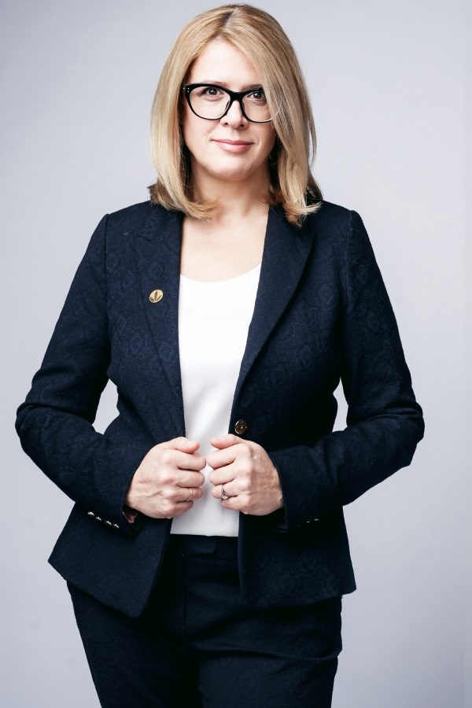
February 9, 2015 – Herbalife announced the appointment of Edyta Kurek as Vice-President of Herbalife in Russia, Ukraine, the CIS, the Baltic States, Mongolia, and Israel. In this role, she will replace Stephen Conchie who is responsible for Herbalife in the Asia-Pacific region starting January 2015. The new appointment is intended to ensure the further growth of the company's business in the Russian-speaking market.

Previously, Edyta Kurek served as Herbalife's Executive Vice-President for Central and Eastern Europe, Middle East, and Scandinavia. In this position, she managed to develop an effective team of highly-skilled professionals,to promote Herbalife growth in the region and to successfully open the company representative offices in 4 new markets (Romania, Moldova, Bulgaria and Lebanon), as well as to transform the company's business in many countries of the region.

Prior to joining Herbalife, Edyta Kurek worked for Oriflame in Poland where during the period from 2001 to 2007 she served as General Manager.

Given her past professional experience and education, Edyta is familiar with the Russian market. She started her career back in 1996 in Moscow at Anixter where she was responsible for launching the company’s Russian subsidiary.

In 1992, Edyta graduated from the Moscow Power Engineering Institute, specializing in nuclear power engineering and thermal physics. In 2010, she received a business consulting degree from the University of Social Sciences and Liberal Arts in Warsaw.

“Edyta’s appointment as Vice President Russia, Ukraine, CIS, Baltics, Mongolia, Israel is an important step in Herbalife development aimed at strengthening our presence in the region. We hope Edyta Kurek’s expertise as an efficient manager and her understanding of the Russian market specifics will help the company in continuing its growth in the area”, said Edi Heinrich, senior Vice President and Managing Director of Herbalife EMEA.
According to Edyta Kurek herself, her primary goal in this new position is to promote the further growth and development of Herbalife in this region through the creation of the most favorable conditions for Herbalife Independent Partners. Being a leader and expert in the field of balanced nutrition, Herbalife has a vast potential for the development in the Russian-speaking market. The interest towards healthy lifestyle in this region is growing every year, which undoubtedly affects the demand for our products and ensures the sustainable business growth of the company's Independent Partners.

The company is actively developing in the Russian market, constantly expanding its business: at this point, there are 51 Herbalife Sales Centers in 48 cities throughout the country. Over the first three quarters of 2014, the net revenue of Herbalife in Russia increased by 34.5% in Russian rubles in comparison to the same period of 2013.

As a part of healthy lifestyle promotion in Russia, the company has been collaborating with the outstanding Russian athletes, including the Olympic champions of 2014 in Ice Dancing in team classification Ekaterina Bobrova and Dmitry Soloviev; the winner of Grand Prix final in figure skating in 2014-2015 Elizaveta Tuktamysheva; the silver medalist of European Championship Artur Gachinsky; and the silver medalist of the Olympic Games in Sochi-2014 in team sprint Nikita Kryukov. The brand ambassadress in Russia is the world star, the prominent gymnast, multiple world and European champion and TV-hostess Lyaisan Utyasheva. Besides that, in 2014 the company continued to support Football Club Spartak as an official nutrition partner of the team.

About Herbalife
Herbalife is a company operating in the healthy lifestyle industry. Since 1980 it has been developing and selling a wide range of products for a balanced nutrition, weight management and personal care on a basis of direct selling model. The company's portfolio is based on the cutting-edge developments in nutrition science and dietology. These products are distributed in more than 90 countries of the world, including Russia and CIS, through the network of Independent Partners.
For reference
HERBALIFE is a global nutrition company, whose activities help people live a healthy and active lifestyle since the company's establishment in 1980. Herbalife's products for a balanced nutrition, weight management and personal care are exclusively sold through the network of Independent Distributors in more than 90 countries of the world. Herbalife shares are listed at the New York Stock Exchange (NYSE: HLF). For more information about the company please visit www.herbalife.ru.
SCIENCE
Herbalife considers providing the highest quality products among its main commitments. In order to create, test and improve product formulas the specialists of Herbalife's scientific center join their forces with the group of independent experts, comprising the Scientific Advisory Board of Herbalife. The board consists of more than twenty prestigious and reputable scholars from various countries, including professor David Heber, the Founding Director of the UCLA Center for Human Nutrition at the University of California, Los Angeles, the specialist in sports medicine Luigi Gratton, Roman Malkov, physiotherapist, gastroenterologist, author of popular books in nutrition science, and many others.
RESEARCH AND DEVELOPMENT
The study "Evaluation of the clinical efficacy and tolerability of diets containing high-protein meal replacement used for the reduction of body weight in obese and overweight people. Randomized controlled clinical study of Herbalife body weight correction program" conducted by the Scientific Research Institute of Nutrition, the Russian Academy of Medical Sciences, has become the fourth scientific substantiation of the effectiveness of the company's products. In addition to this study, the efficiency of Herbalife's products, particularly, the protein shake "Formula 1", has been confirmed by clinical studies of three other global leading institutions in the field of nutritional science. In addition to the study by the Scientific Research Institute of Nutrition, Russian Academy of Medical Sciences, the approval of efficacy of protein shakes 'Formula 1' was obtained in the USA (University of California), in Germany (University of Ulm, and in South Korea (Seoul National University)
The main aim of a research conducted in the clinics of the Institute of Nutrition, the Russian Academy of Medical Sciences, over the period of three month and covering 90 individuals, was to provide the assessment of clinical efficacy and tolerability of diets containing high-protein meal replacement, used for the reduction of body weight in obese and overweight people. In total, the study of product efficacy consisted of three various stages: selection of participants, body weight reduction program and weight control phase. The study was covering people aged 21 to 60, suffering from overweight, but who don't have any substantial health problems or other contraindications (like pregnancy, weight control medications, loss of weight exceeding 6 kg the past 6 months prior to the study, etc.) The researchers evaluated the effects of Herbalife products on body weight, arterial blood pressure, body composition and biochemical parameters of blood during the body weight correction program. The important additional aspect of the study was evaluation of tolerability, cloyingness and safety of Herbalife's products.
The results of this clinical study prove that Herbalife's body weight reduction programs based on "Formula 1" and "Formula 3" products are more efficient in comparison to the traditional low-calorie diet for reducing body fat mass, waist circumference reduction, while making the whole process of body weight control more comfortable, namely, providing saturation and avoiding hunger. According to the results of this study these product were approved by the National Association of Dietitians and Nutritionists of Russia.
SPORTS
Over the period of 2008-2013, Herbalife sponsored more than 100 global and regional sporting events. The company is a nutrition sponsor for more than 25 leading football clubs of the world, including such prominent teams as "Spartak-Moscow" (Russia), "Shakhtyor" (Ukraine), and is the title sponsor of the major league soccer team LA Galaxy (USA). Starting 2013, the Herbalife ambassadress in Russia is the Honored Master of Sports in Modern Rhythmic Gymnastics, world champion in team classification and double champion of Europe in team classification, six-time world cup winner, silver winner of world games in Akita (Japan), participant of TOP-100 most beautiful ladies of the world, the winner of American Chamber of Commerce award "For best return to sports", the international ambassador of the Olympic movement Sochi-2014, sportcaster and TV hostess Lyaisan Utyasheva. Besides that, starting 2013 Herbalife is an official nutrition partner for the following athletes: the Russian skier, the champion of XXI Winter Olympic games of 2010 and silver winner of XXII Winter Olympic games of 2014 Nikita Kryukov; Russian figure skating dancing couple, champions of Europe and Russia, Champions of XXII Olympic Winter Games of 2014 in team classification Ekaterina Bobrova and Dmitry Soloviev; the Russian figure skating, single skating, winner of world championship and championship of Europe of 2011 and 2012 Artur Gachinsky, and the Russian figure skater, winner of Gran Prix final in figure skating in 2014-2015 Elizaveta Tuktamysheva.
INDUSTRY LEADERSHIP
Herbalife is an active participant of more than 70 scientific, industrial and public organizations, such as the World Federation of Direct Selling Associations and the Russian Direct Selling Association. Herbalife is one of the founding members of the International Alliance of Dietary/Food Supplement Associations (IADSA), European Responsible Nutrition Alliance (ERNA), and the Council for Responsible Nutrition (CRN). In Russia Herbalife also participates in the Non-Commercial Partnership of Dietary Supplements Manufacturers and the National Association of Dietitians and Nutritionists of Russia.

Randomized controlled clinical study of Herbalife® body weight correction program. June 2011, Scientific Research Institute of Nutrition, Russian Academy of Medical Sciences, Moscow. For more information, please, visit: http://www.herbalife.ru/about/science/clinic/

