Press release
December 2017
Brother launches new scanner series built for business
Reflecting customer research, office technology specialist Brother has launched a new generation of scanners which are fast, compact, easy to use and built for business.
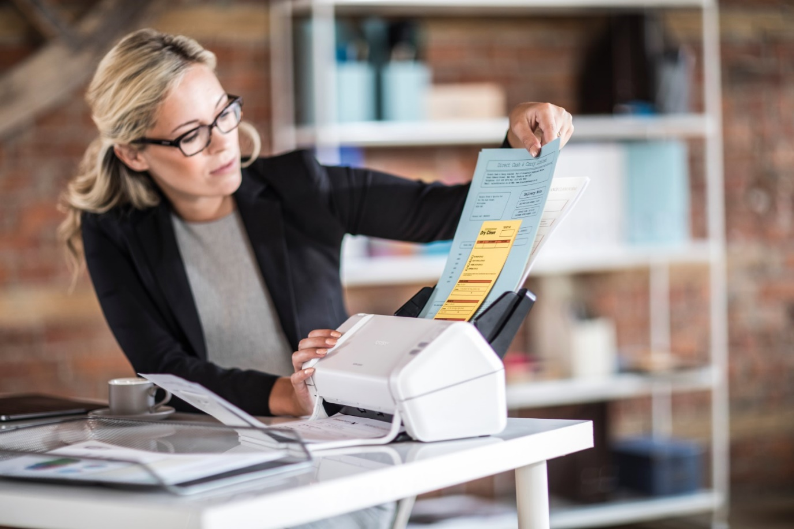
Brother ADS-2200
Aimed at SMB and hard copy heavy SOHOs, the ADS-2200 and ADS-2700W boast key new features and scan 45% faster than its predecessor range¹.
Brother’s research revealed that 51% of businesses use single function desktop scanners and/or mobile scanners^{2.}
Public administration, manufacturing, insurance and finance were identified as sectors with the highest scanning volumes. Addressing this, the series can handle a range of media capacities including double-sided A4 paper, photo paper, plastic ID and embossed cards up to 1.32mm thick, and receipts in one batch, preventing the need to pre-sort.
The series is easy-to-use with automatic scanning to pre-set destinations, minimising customer input. The range can scan direct to USB memory sticks, eliminating the need to turn on a computer, benefitting the user if they need to scan a document quickly for a meeting or upload documents for a colleague.
The range is fast, scanning up to 35 double-sided, colour documents per minute.
When the output tray is folded into the unit’s body, the range has similar width and depth dimensions to a single piece of A4 paper, meaning it can fit seamlessly into any office.
To improve user experience, the range enhances the quality of the image through built-in image processing and document correction tools.
Further features include hole punch removal, colour tone adjustment, removal of marks and ink blots, edge clean-up, ruled line removal and character enhancement. These options ensure documents are optimised and business-ready, minimising user input.
The flagship ADS-2700W model boasts advanced features of Wired LAN, wireless Wi-Fi connectivity, scan to network folder and File Transfer Protocol (FTP) and Secure File Transfer Protocol (SFTP). Compatible with Windows, macOS and Linux operating systems, the scanners are easily integrated into businesses.
The 7.1cm LCD colour touchscreen on the flagship model allows scanned documents to be instantly sent to pre-configured profiles, saving preparation time. A lockdown feature can be activated to ensure higher levels of office security, complementing the research that showed 45% of businesses are required to meet confidential, legal or regulatory standards.
The ADS-2200 has a simple button operation for one-touch efficient scanning.
Aleksey Gorbunov, Business Development Manager at Brother LLC said: “This is a stand-out scanner range from Brother and has been built with R&D that has responded to the needs of the customer.
“Combining ease of use, fast speed, versatile document handling and compatibility, the range is ideal for SMB and SOHO use.”
The new scanner range already available in Russia.

¹ The ADS-2200 and ADS-2700W scan at speeds 45% faster than its predecessor range, the ADS-2100e and ADS-2600We.
² Data taken from B2B International research conducted on behalf of Brother International Europe in 2016 amongst 1,957 desktop and/or mobile scanner purchase decision-makers in businesses between 1-249 employees in UK, France, Germany, Italy and Spain.

Range specification
ADS-2200
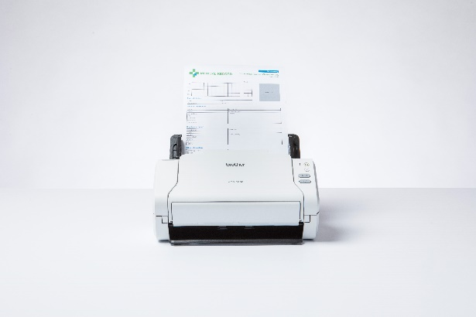
- 35ppm/70ipm double sided colour scan speeds
Brother ADS-2200
- One-touch simple scan option
- Hi-Speed USB 2.0 connectivity
- 50-sheet mixed media auto-feeder (suitable for A4, photo paper, receipts, plastic ID cards and embossed cards)
- Scan to functions including searchable PDF, file, OCR, email and USB memory sticks
- Up to 1200 x 1200dpi (interpolated) resolution
- Supports PC, macOS, Linux systems
- Includes document management and business card software for PC and Mac
- Device dimensions without input tray (mm) W 299 x D 145 x H 141

ADS-2700W
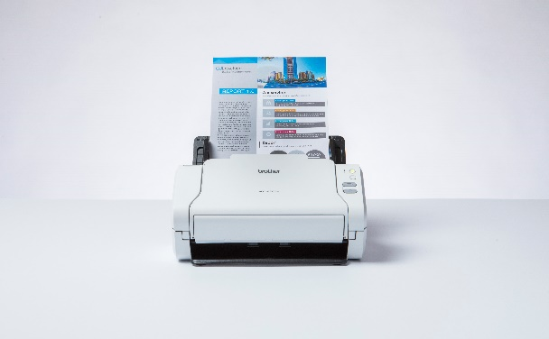
- 35ppm/70ipm double sided colour scan speeds
Brother ADS-2700W
- Zero-touch simple scan option
- Wired LAN, Wi-Fi and Hi-Speed USB 2.0 connectivity
- 50-sheet mixed media auto-feeder (suitable for A4, photo paper, receipts, plastic ID cards and embossed cards)
- Scan to functions including searchable PDF, file, OCR, email server, network folder, FTP/SFTP and USB flash drive
- Up to 1200 x 1200dpi (interpolated) resolution
- Supports PC, macOS, Linux systems
- Includes document management and business card software for PC and Mac
- 7.1cm LCD colour touchscreen
- Device dimensions without input tray (mm) W 299 x D 145 x H 141
За более подробной информацией обращайтесь в компанию Brother.
Контактное лицо: Анастасия Сердюк, специалист по маркетингу.
Тел.: +7 (495) 510-50-50 (доб. 57)
e-mail: Anastasiya.Serdyuk@brother.ru
Официальный сайт Brother: http://www.brother.ru

