Brother launches two new models of label printers
New Brother QL-800 and QL-810W are the perfect choice for office workers who need a reliable and fast address label printer.
Thanks to the integrated P-touch Editor Lite label design software it is so easy to use - simply connect to your computer, click the icon to launch the software and design and print your labels. Or use the advanced P-touch Editor label design software to include barcodes, images, and other advanced functions.
You're also able to produce labels with both black and red print without the need of ink or toner - ideal to highlight important information on a label.
And the integrated cutter allows custom sized labels up to one metre in length when using one of the continuous label rolls.
QL-800

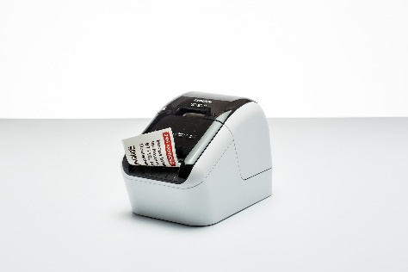
Key Features
- USB connectivity for quick and easy set-up
- Print labels up to 62mm wide from your PC or Mac
- Built-in label editing software doesn't need installing. Simply click to run
QL-800
- Print in black and red without needing ink or toner
- Print on pre sized labels (for your address or shipping labels) or continuous rolls up to 62mm wide (for indoor/outdoor signage)

QL-810W

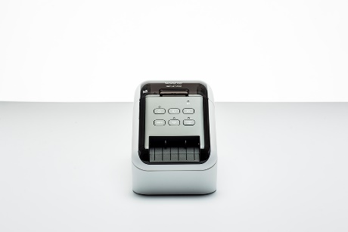
Key Features
- USB and Wi-Fi connectivity with AirPrint support
- Print on pre sized labels (for your address or shipping labels) or continuous rolls up to 62mm wide (for indoor/outdoor signage) from PC, Mac, smartphone or tablet
QL-810W
- Built-in label editing software doesn't need installing. Simply click to run
- Print in black and red without needing ink or toner
- Integrated cutter to create your own length labels
- Optional rechargeable Li-ion battery base for mobile labelling applications

For more information please contact: Anastasiya Serdyuk, Marketing specialist
Tel.: +7 (495) 510-50-50 (ext. 57)
e-mail: Anastasiya.Serdyuk@brother.ru
Brother web-site: http://www.brother.ru

