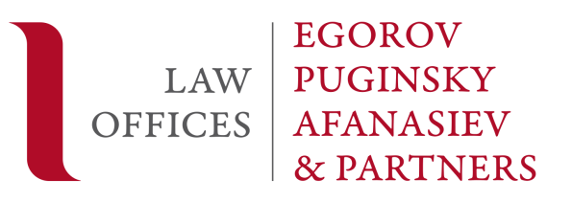

Evgeny Gurchenko is listed in international Acritas Stars Best Lawyers Ranking
Evgeny Gurchenko is listed in international Acritas Stars Best Lawyers Ranking
Evgeny Gurchenko, a Senior Associate at Egorov Puginsky Afanasiev & Partners’ St. Petersburg Litigation Practice, has been top listed by Acritas Stars, a database of client-nominated stand-out lawyers in private practice launched by Acritas, legal market analysis, research and advisory services British-American firm. The rating has become a result of a Stand-out Talent survey among more than 3,000 senior in-house counsels around the world.

The clients have emphasized that Evgeny is “a very knowledgeable expert in many areas” and noted that they “know him as a good litigation lawyer”. “His brain works very quickly and he can also solve multiple tasks at the same time. He always responds to our requests very quickly”. "He perfectly conducts the litigation process, he has a sharp mind, and correctly answers all questions concerning litigation," as the respondents have highlighted.
For over 9 years, Evgeny has been focused on representing domestic and international companies in litigations over real estate and construction, corporate governance, bankruptcy and restructuring, as well as banking and finance. Evgeny is engaged in multi-billion proceedings in international commercial arbitration and before foreign courts.
Evgeny advises on restructuring of company assets, namely in case of international sanctions being applied to companies, and represents clients in related disputes. He counselled a Russian credit institution as related to the EU and the US sanctions imposed thereon, and namely advised on restructuring of assets, secure structuring of business processes due to existing restrictions and defended a client in the course of releasing the moneys blocked in a US bank.
He was also involved in amending of the Law “On Insolvency” and the Law “On Insolvency of Credit Institutions as commissioned by the Deposit Insurance Agency, amendments to the Law “On Competition Protection” (as related to the unfair competition section) within the FAS of Russia’s task force, amendments to the Russian Civil Code with regard to trademarks as commissioned by a large FMCG company.
Evgeny also has necessary qualifications and an extensive experience in private client services, including those related to settlement of family and inheritance disputes.
He is a best arbitration lawyer according to the general industry choice ratings by Pravo.ru.
Click here for more details on Acritas Stars ratings.

MORE INFORMATION
pr_spb@epam.ru
+7 812 322 96 81
Alina Volkova

