The 15,000th PONSSE delivered to Lespromindustria
Today, the 15,000th PONSSE forest machine was completed at Ponsse’s factory in Vieremä and delivered to Lespromindustria from Russia. The machine delivery also represented a step towards Ponsse’s 50th anniversary to be celebrated next year. Fifty years of logging will be celebrated by a global roadshow together with Ponsse’s customers and other forest industry professionals.
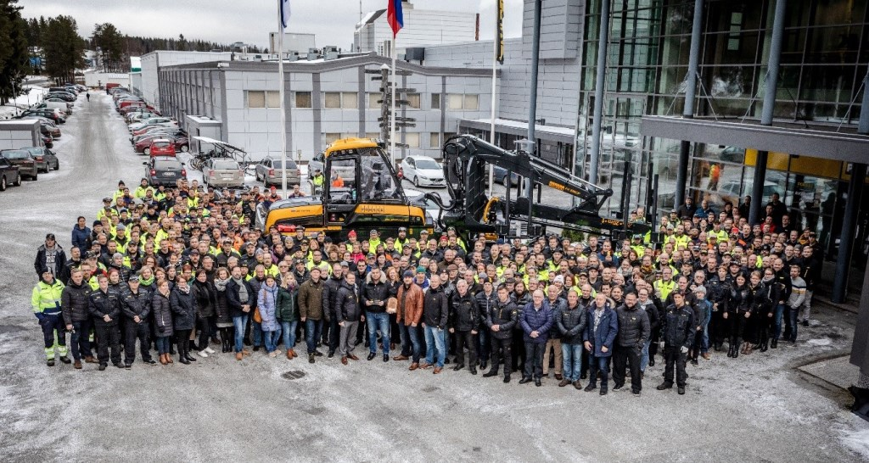
The PONSSE Buffalo delivered today will operate in Tomsk as a partner for a new PONSSE Ergo. Lespromindustria is a significant seller of sawn goods in its region, and it has 12 PONSSE forest machines. Next year, Ponsse will open a new service centre in Tomsk, and also build a new service centre in Joensuu.
The 15,000th PONSSE was manufactured at the new factory opened a year ago. It was the most significant investment in the company’s history at nearly EUR 40 million. The significant investment in the future has proved its worth along the way towards continuous development. The amount of testing and quality control has increased considerably. For example, the factory features an optical 3D scanning unit, representing the latest technology, to inspect all forest machine structures at extreme precision and ensure that all structures meet their quality requirements. At the same time, the factory has been modernised in terms of eco-friendliness and ergonomics. Flexible working methods enable the broadest product range in the markets and reactions to changing market needs. Soon, the 1,000th PONSSE Scorpion, the flagship of the model range, will exit the production line.
The Vieremä factory has grown to cover an area of nearly four hectares. It is still based around a 300 square metre hall from where it all started 50 years ago. The oldest still-operational forest machine factory in Finland forms the core of Ponsse’s production.

