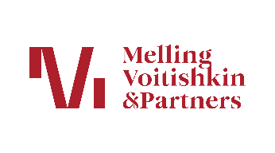 | Additional information:  Uliana Malenskaya  Communications Manager  +7 495 787 27 00  uliana.malenskaya@mv.legal

Melling, Voitishkin & Partners Releases its 2026 Doing Business in Russia Guide
28 April 2026
Melling, Voitishkin & Partners announces the latest edition of its guide for navigating the Russian market, "Doing Business in Russia 2026". This guide offers a comprehensive analysis of the Russian legal system and provides up-to-date information on the regulations for conducting business in the country.
The manual covers a wide range of topics, including the establishment and operation of legal entities, taxation, banking and finance law, antimonopoly regulation, and customs legislation. It also addresses legal frameworks in the areas of environmental protection, labor relations, intellectual property, natural resources, sanctions, and telecommunications.
The guide was authored by experts from Melling, Voitishkin & Partners - practicing lawyers with extensive experience in providing legal support to businesses operating in Russia.

