Brother HL-L9310CDW picked as outstanding colour printer for SMBs
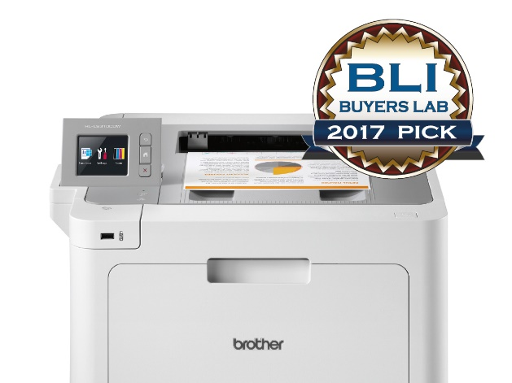
Brother HL-L9310CDW was highly recommended by the Buyers Lab (BLI) Summer Pick Awards 2017 as outstanding colour printer.
BLI awarded HL-L9310CDW with a certificate of reliability after rating the model for its value, image quality, usability, features and speed.
The highly-respected BLI Pick Awards are some of the industry’s toughest to achieve, with experienced analysts putting products through two months of rigorous testing to find a winner.

David Sweetnam, Director of Research and Lab Services for BLI EMEA/Asia, said: “The colour laser printer performed flawlessly throughout BLI’s 80,000-impression durability test, with no misfeeds and no service calls required.
“Thanks to simple procedures for replacing supplies, high-yield consumables and a class-leading maximum paper capacity of 2,380 sheets, the HL-L9310CDW promises maximum uptime for busy workgroups.
“This device is competitively priced and has a lower than average cost per page, which makes it a very good value proposition. BLI highly recommends the Brother HL-L9310CDW for mid-size workgroup environments.”
The judges highlighted several benefits of the device including:
- Highly reliable performance combined with simple routine maintenance
- Strong value proposition based on performance, features and cost of ownership
- Strong feature set including colour touchscreen, BSI open architecture platform, built-in NFC for mobile printing and badge authentication, standard wired and wireless interfaces and secure printing
- Print from a wide range of cloud services through Brother’s Web Connect technology
- Professional quality output with above average darkness and sharpness of text
- Direct printing from USB flash drives
- Simple driver installation routine
- Straightforward process for loading paper and removing misfeeds
Pavel Tikhonov, Product marketing manager at Brother LLC, said: “We are extremely proud that the HL-L9310CDW has received this highly credible award - one of the toughest accolades to achieve in the industry.
“The device was developed with technology to help SMBs thrive and become more efficient. Following the rigorous testing, feedback from the judges confirms that the machine is an excellent choice for modern offices.”

