Press release
November 2017
Brother wins Good Design Award for 25th consecutive year
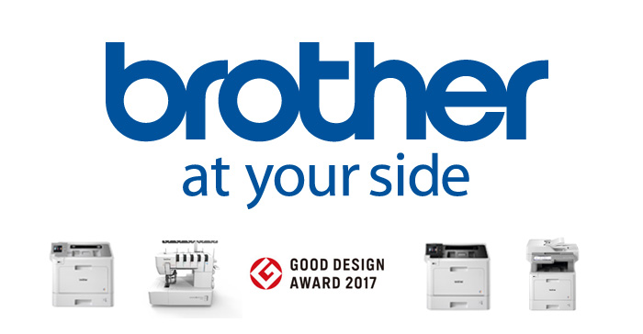
Brother has been recognised for its high-quality product design for the 25th year running after winning a Good Design Award 2017 in the Colour Multi-Function Laser Series category.
The HL-L8360CDW*, MFC-L9570CDW and HL-L9310CDW printers and multi-function device from the print specialist’s latest colour laser range scooped the Japanese award.
Additionally, the CV3550 Double Cover Stitch Machine also came out on top in the Cover Stitch Sewing Machine category.
Since Brother first won the award for its home sewing machine in 1960, it has claimed the Good Design Award for 199 different products.
Based on its motto, “At your side”, Brother continues to strive to provide superior value through product design, placing its customers first by designing products that suit their needs.
Pavel Tikhonov, Product marketing manager at Brother Russia, said “The Good Design Award recognises not only the exterior beauty of products, but also the user experience and environmental impact of the design, as well as the product’s innovative qualities. Winning the award highlights the hard work of all Brother employees involved in developing, manufacturing and delivering our products and services.’’

For more information, please contact:
Serdyuk Anastasiya, Marketing specialist
Tel.: +7 (495) 510-50-50 (ext. 57)
Anastasiya.Serdyuk@brother.ru
http://www.brother.ru

*not available in Russia.

