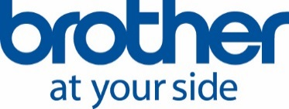
Press release
10, April 2018

Design quality of Brother products secures prestigious awards

Print and technology solutions provider Brother is celebrating a win of iF Design Awards for colour laser devices.
The winning products include colour laser multifunction printer MFC-L9570CDW, which also scooped a Winter 2018 Pick Award from independent tester Keypoint Intelligence – Buyers Lab. The device was celebrated by Buyers Lab for its image quality, exceptional scan speed and reliability.
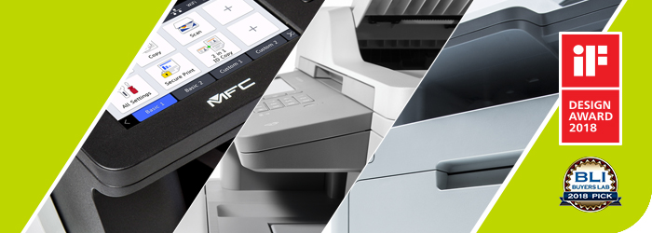
Products are judged for iF Design Awards not only on their external appearance, but also quality, performance, user interface, innovation, safety and environmental credentials.
The following Brother colour laser devices were awarded iF accolades for 2018 - MFC-L9570CDW, MFC-L8650CDW, DCP-L8410CDW, HL-L9310CDW, HL-L8260CDW.
Sarkis Baseyan, Sales and Marketing Director from Brother LLC said: “It’s a great honour to receive one of the most highly-respected and widely-known design awards in the world. It is an incredible achievement, particularly with the MFC-L9570CDW also winning a Buyers Lab Winter 2018 Pick Award.
“At Brother, we strive to continually evolve our products to develop new and unique solutions for our customers. Our impressive count of 66 iF Design Awards has shown that we have accomplished that.”
Brother won its first iF Design Award for the alphanumeric typewriter in 1982. The awards are hosted and judged by the International Forum Design, in Hannover, Germany. This year the iF Design Awards received 6,401 entries from 54 countries.
About the iF Design Awards
The iF DESIGN AWARD is among the most prestigious and largest design competitions in the world. Since 1953, designers, manufacturers and users have looked to iF as a sign of good design.
An iF DESIGN AWARD is a seal of excellence, a testimony of quality, and a challenge to the competition. For users, it is a symbol of trust.
For more information, visit: https://ifworlddesignguide.com/if-design-award-2018

For more information please contact: Anastasiya Serdyuk, Marketing specialist
Tel.: +7 (495) 510-50-50 (ext. 57)
E-mail: Anastasiya.Serdyuk@brother.ru
Brother web-site: http://www.brother.ru

