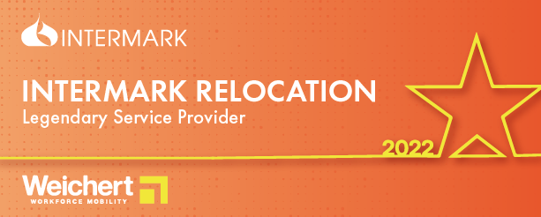Intermark receives Weichert ‘Legendary Service Provider’ award
27/10/2022

Intermark is happy and proud to receive a special award from one of its largest clients, Weichert. This award recognizes the well-coordinated teamwork, involvement of each employee and the high quality of presenting information.

Intermark would like to thank Weichert for their appreciation of our work and mutually beneficial and positive cooperation and valued partnership.

"At the Worldwide ERC Global Conference in Las Vegas, Weichert presented us with a special ‘Legendary Service Provider’ award," said Irina Yakimenko, Intermark Managing Partner. “We are incredibly pleased and very appreciative to receive such esteemed recognition, especially during these challenging times. We strive to be ahead of service expectations and help all of our clients to solve and consult on their challenges in the most effective way”.

ABOUT INTERMARK
Intermark is a relocation consultancy that provides full scope in-bound immigration, relocation and HHG moving services in more than 10 countries, including Azerbaijan, Belarus, Georgia, Kazakhstan, Russia, Ukraine, Uzbekistan and others, as well as outbound services worldwide through a wide network of international partners.

ABOUT WEICHERT
Weichert Workforce Mobility helps companies build stronger, more cost-effective relocation programs, making it incredibly easy to deploy key talent and transfer critical skills, anywhere in the world. The company was founded in 1969 and to this day, remains under the same ownership, providing a level of confidence and stability that is unmatched within the relocation industry.

Contact:
Anna Vaganova
PR Specialist
+7 (967) 212 95 02
A.Vaganova@intermarkrelocation.com

