Sergey Mozhenin becomes a new Antal, Russia Partner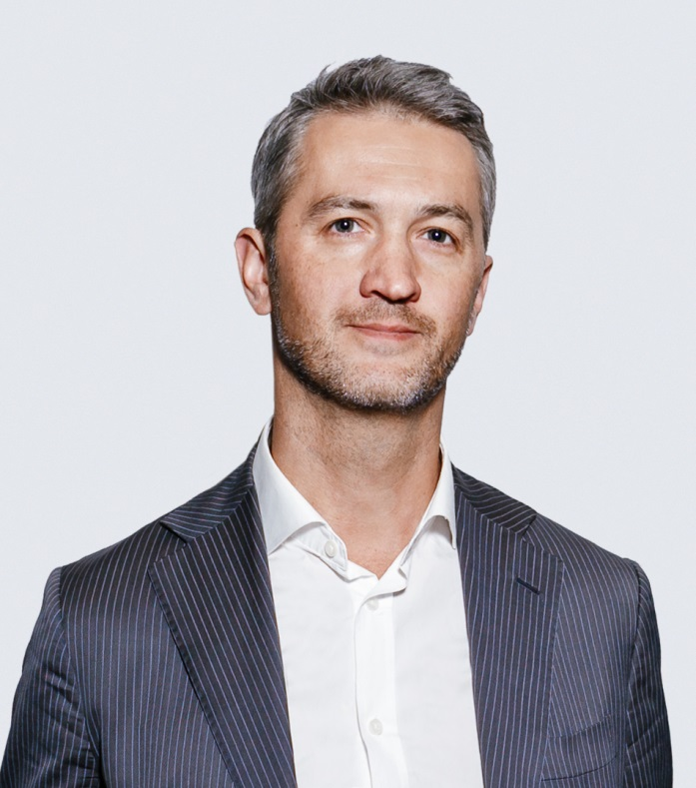
Sergey Mozhenin joined Antal, Russia as a Partner. He became the Head of the Back Office Recruitment Department which includes the following practices: Finance and Accounting, HR, and Legal.
Sergey has spent many years working in companies engaged in professional services in IT and in consulting. Before joining Antal, he held senior management positions in Lucent Technologies, MTS, IBS, BDO Russia, Ernst & Young, Crowe Horwath Russia.
"Companies give increasing attention to financial and compliance processes, so specialists in this field grow in importance, and even an HR Director now has to have a much deeper understanding of these aspects of the business. Professional financial services is just the area where Sergey has extensive experience. Thanks to his expertise, our clients will receive an even more comprehensive assistance in financial, legal, and HR recruitment," said Michael Germershausen, Managing Director, Antal Russia, commenting on the appointment of Sergey Mozhenin.

