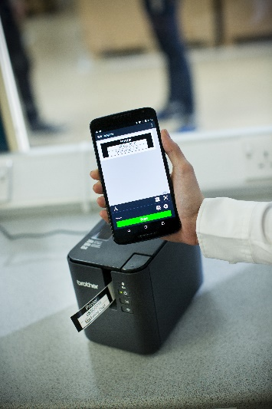
Improved app means business for customers
Creating labels has just got easier for customers as Brother launches a new version of its successful iPrint&Label app, supporting the increasing use of smartphones and tablets in the workplace.
Providing versatility, labels can now be created on the computer through the P-touch Editor label design software, then simply emailed to the smartphone or tablet to print, save or edit on the mobile app. This supports the increase of flexible working with employees using a combination of computers, smartphones and tablets.
Features of the iPrint&Label app version 5.0 include:
- Ability to add boxes, lines and move objects through drag, drop, resize and rotate functionalities, only previously available on a desktop computer.
- The choice of hundreds of symbols and clip-art.
- Option to add images, photos and logos to your label.
- Adding barcodes to labels, including the popular QR code 2D barcode.
- Include a date/time, which is automatically updated to show when the label was printed. The option of a future calculated date/time, ideal for “use by” or “shred/destroy” items is available.
- Improved and modern looking user interface making the process more efficient for users as their templates can be accessed through just one click if reproducing previous labels.
- Allowing contact details from your device including name, phone number and address to be inputted into a label.
Now providing the option of creating black and red print, the app allows users to create standout two colour labels using Brother’s game-changing QL-810W labelling printer.
The app works with PT-P900W device which provides advanced labelling solutions for the office, retail, catering, healthcare and facilities management sectors.
Other compatible models are workplace devices: QL-710W, QL-720NW, PT-P750W and the PT-E550WVP, specifically designed for electricians.
Pavel Tikhonov, Product marketing manager at Brother LLC said: “As the popularity of our iPrint&Label app and employees working from multiple devices continues to soar, our software has been developed to reflect these changes. Version 5.0 also allows users to have more control of the design, therefore creating labels which have a bigger impact.”
To download Brother’s iPrint&Label app, visit:
https://itunes.apple.com/ru/app/brother-iprint-label/id523047493?mt=8
https://play.google.com/store/apps/details?id=com.brother.ptouch.iprintandlabel&hl=ru
* Brother’s iPrint&Label version 5.0 requires iOS 9 or above, or Android version 4.4 or above.

