February 2018
Latest colour laser line up from Brother praised by BLI
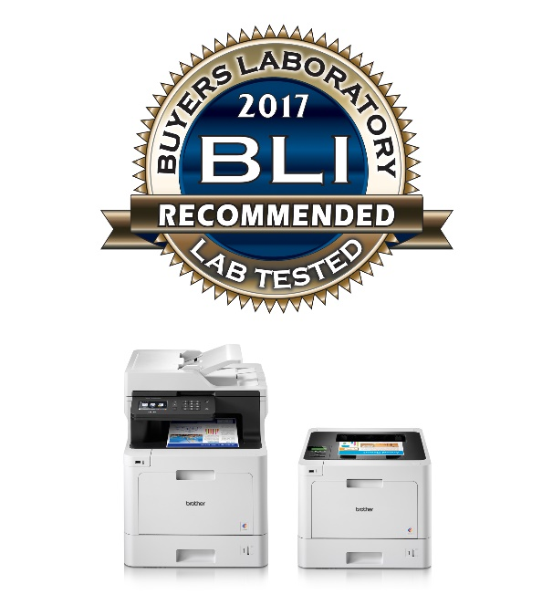
Customers choosing Brother’s latest colour laser series can rest assured they will have a reliable device after all models in the range were highly recommended or recommended by the Buyers Lab (BLI).
The world-leading independent tester awarded the machines with the certificate of reliability after rating the models for their value, image quality, usability, features, speed and reliability.
Multi-function devices MFC-L8690CDW, MFC-L9570CDW and printer HL-L9310CDW were highly recommended, whilst the DCP-L8410CDW and HL-L8260CDW were recommended.
Recommendation from BLI is highly-respected and one of the industry’s toughest ratings to achieve, with experienced analysts putting products through two months of rigorous assessment.
No misfeeds were reported on any of the devices during an 80,000-impression durability test. No post-test servicing was required on any device either, securing an excellent rating for reliability.
The analysts highlighted several benefits of the range including:
- Reliable performance combined with simple routine maintenance
- Strong feature set
- Print from a wide range of cloud services through Brother’s Web Connect technology
- Supports printing from tablets and smartphones with multi-function devices supporting scanning to mobile devices.

For more information please contact: Anastasiya Serdyuk, Marketing specialist
Tel.: +7 (495) 510-50-50 (ext. 57)
e-mail: Anastasiya.Serdyuk@brother.ru
Brother web-site: http://www.brother.ru

