Press release
1, March 2018
Brother’s latest high capacity Ink Tank series mean customers can print more and spend less.
Customers can print more and spend less with Brother’s new and improved Inkbenefit Plus range, which is convenient, durable and affordable.
Comprising three machines - the DCP-T310, DCP-T510W, DCP-T710W – the series is designed for both home and small offices.
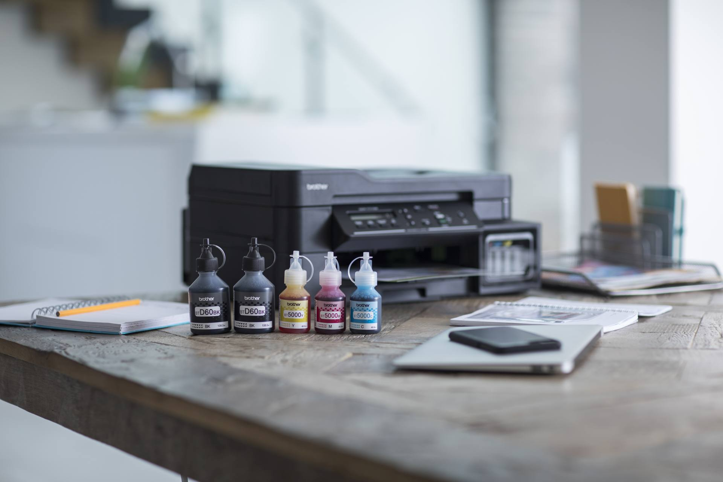
Brother DCP-T710W
Offering significantly low cost per page, the range features Brother’s ink tank refill system which boasts a 6500 page yield for black and 5000 page yield for individual colour inks (C, M, Y) yield. The Brother ink bottles achieve ultra-high print volumes, reducing the regularity of ink replenishment and downtime of the device.
Increasing the cost-efficiency further, all devices come with bottles of all four ink colours¹ - black, magenta, cyan and yellow - so customers can start printing immediately with no initial consumable costs.

The new Inkbenefit Plus range comes in a compact design, meaning it can fit seamlessly into any small or home office and the quiet mode function keeps noise at a minimum, making an unobtrusive addition to any sized office.
Supporting flexible working, the DCP-T510, DCP-T710W devices have wireless connectivity, allowing employees to print no matter what device they are using – a tablet, smartphone, laptop or desktop computer.
The range is fast, with the flagship device printing 10 impressions per minute (ipm) in colour and 12ipm in mono. The series also offers speedy scanning, with a 100dpi scan taking just 4.38 seconds in colour and 3.5 seconds in mono.
The flagship model is feature-rich with automatic duplex print, a user-friendly 4.5cm colour LCD, direct photo printing from USB flash drive and 80-sheet multi-purpose tray – supporting printing on varying paper stock including envelopes and card.
The DCP-T710W machines have a 20-sheet Automatic Document Feeder (ADF), allowing multiple sheeted documents to be scanned or copied as a batch – rather than laboriously feeding pages in sheet-by-sheet.
Pavel Tikhonov, Product marketing manager from Brother LLC said: “Our ink tank refill system means that customers will get higher print volumes and the cost per page of the devices is minimised as consumables will be replenished less frequently.
“The new Inkbenefit Plus range is catered around the needs of small and home-based businesses to be convenient, durable and affordable.
“Packed with features, it not only makes the customers’ life easier, but saves them money, without compromising on print quality.”
The range will be available in Russia from March 2018.
¹DCP-T510W, DCP-T710W devices come with 2x black, 1x cyan, 1x magenta and 1x yellow box inks. The DCP-T310 comes with 1x black, 1x cyan, 1x magenta and 1x yellow box inks.

For more information please contact: Anastasiya Serdyuk, Marketing specialist
Tel.: +7 (495) 510-50-50 (ext. 57)
E-mail: Anastasiya.Serdyuk@brother.ru
Brother web-site: http://www.brother.ru

