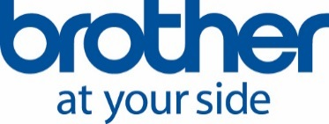

May 10, 2018

Brother team (Russia), together with its partners, returned from a trip across Iceland

Brother, a company specializing in printing technologies, and its partners travelled to Iceland from 18 to 24 April 2018. The trip was a bonus for the company's partners based on their 2017 fiscal year performance.
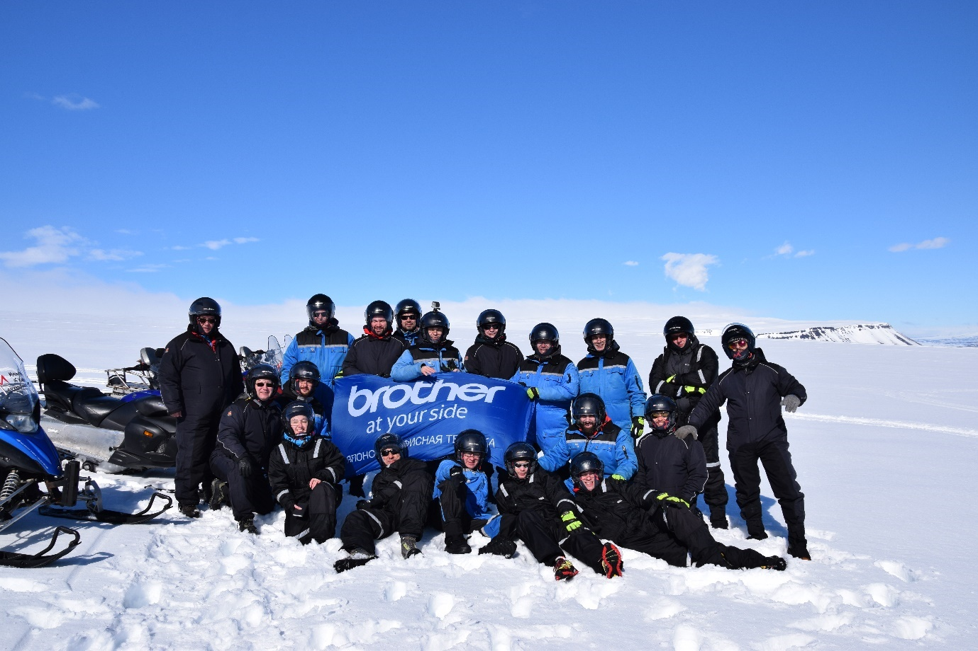
Brother trip to Iceland, April 2018.
Partners and employees of the company went to Iceland for a week where they were waited by the rich excursion program, which included snowmobile riding around the glacier, visiting the thermal spring, sea fishing, getting to know the traditional cuisine of Iceland and much more.
During the trip, the participants made tours to the most beautiful places of the southern coast of Iceland, visited the Reykjanes Peninsula with fantastic lava landscapes and rested in the famous Blue Lagoon geothermal spa.
The trip allowed everyone to recharge with energy and positive emotions.

For more details, please contact Brother.
Contact person: Anastasiya Serdyuk, Marketing Specialist.
Tel.: +7 (495) 510-50-50 (ext. 57)
e-mail: Anastasiya.Serdyuk@brother.ru

Brother official website: http://www.brother.ru

