INTERMARK RECEIVES TOP LEVEL
CARTUS COMMITMENT TO EXCELLENCE PLATINUM AWARD
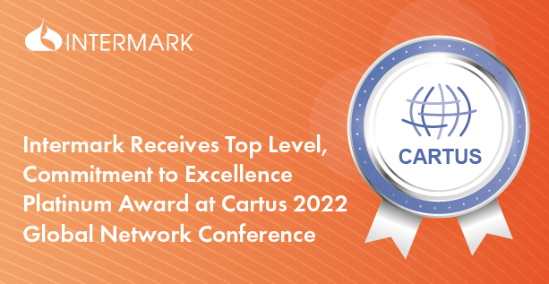

24/10/2022

Intermark was recently honored to receive Commitment to Excellence Platinum Award at Cartus 2022 Global Network Conference held virtually from October 3-5, 2022 in recognition and appreciation of its outstanding contributions and commitment to quality, exceptional service, and innovation in the changing face of relocation.

“We’re proud to be a part of Cartus’ Global Network, and to have received this accolade, which recognizes our commitment to quality and excellence, and our ability to source innovative ways to meet relocation challenges, especially in unprecedented times like today”, said Irina Yakimenko, Intermark Managing partner. “This award really belong to our team who are showing unprecedented perseverance, loyalty and passion for their work”.

“When serving our Cartus clients and customers, Intermark demonstrates the highest caliber of excellence every day. Congratulations on a well-deserved win.” said Eric Barnes, CFO and Senior Vice President of Supply Chain Management.

The event’s theme was “Leading the Way, Anywhere,” reflecting the industry-leading partnerships and global scope the Cartus Global Network represents. Each year, Cartus recognizes the companies and individuals in the Network who have provided extraordinary service to its customers and clients worldwide.

ABOUT INTERMARK
Intermark is a relocation consultancy that provides full scope in-bound immigration, relocation and HHG moving services in more than 10 countries, including Azerbaijan, Belarus, Georgia, Kazakhstan, Russia, Ukraine, Uzbekistan and others, as well as outbound services worldwide through a wide network of international partners.

ABOUT CARTUS
Cartus Corporation, a global leader in talent mobility and distributed workforce solutions, delivers the full spectrum of corporate relocation services to organizations of all sizes across the world. These include more than a third of Fortune 100 companies as well as hundreds of clients with small-to-mid-size programs serviced through their dedicated Cartus InsigniaSM segment.

Contact:
Anna Vaganova
PR Specialist
+7 (967) 212 95 02
A.Vaganova@intermarkrelocation.com

