Ponsse opened a new training centre in St. Petersburg
The grand opening of the new training and service centre of OOO Ponsse, Ponsse’s subsidiary in Russia, was celebrated last week in Gorelovo, St. Petersburg. With its area of 1,500 square metres, the new training centre is one of the company’s largest investments in Russia, totalling approximately EUR 3 million.
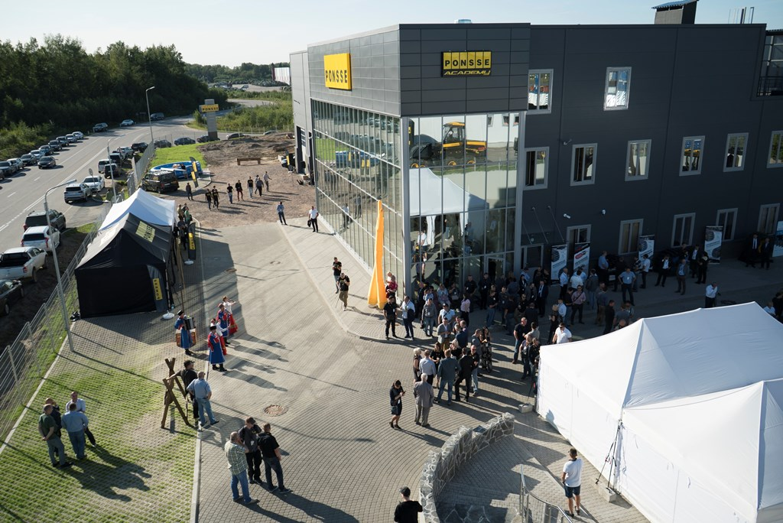
The new training centre is the flagship of OOO Ponsse’s training network, featuring the best training equipment and skills in the industry. Jaakko Laurila, Managing Director of OOO Ponsse, says that the company is a pioneer in the development of training services.
“We want to offer the best training services in this industry. This new training centre is exceptional in terms of its quality and training content. High-quality training services give us a significant competitive edge and enable us to increase our market share”, Laurila says.
The new training and service centre in St. Petersburg features all PONSSE simulator models for operator training and a test track for practical training. Mechanics are trained in service facilities that have room for three forest machines at the same time.
Growing market requires training services
In just over ten years, large parts of Russia have shifted from tree-length harvesting to the more efficient and eco-friendlier cut-to-length (CTL) method. Currently, Russia is the world’s largest forest machine market. This can be seen not only through increased forest machine sales, but also as a growing need for training and maintenance services. Russia does not offer any official training for forest machine operators and mechanics, which strengthens the importance of Ponsse’s training range even further. Studies have shown that high professional skills of operators play an important part in terms of productivity.
Ponsse’s subsidiary in Russia was established in 2005 and, nearly ever since, the company has worked with educational institutions in the field of forestry. Currently, Ponsse’s training network comprises, in addition to the new unit opened in St. Petersburg, a training and service centre in Pitkyaranta and 17 training units that work in cooperation with vocational and higher level educational institutions in different parts of Russia and Belarus.
The highly advanced training range covers not only operator and mechanic training, but also training programmes for the management of the harvesting process, productive harvesting and thinning. The training range has been designed for Ponsse’s operators, mechanics and customers, the PONSSE network’s retailers and personnel, as well as teachers of educational institutions in the field of forestry. The duration of training periods spans from a few days to one month. Training manager Nikolai Chernutskii is in charge of OOO Ponsse’s training services.
OOO Ponsse has 120 employees in Russia, as well as an extensive retailer network which enables nationwide operations. Approximately 2,000 PONSSE forest machines operate in Russia. The company has service centers in St. Petersburg, Pitkyaranta, Segezha, Tihkvin and Tomsk.

