Dentons launches in Scotland

World's largest law firm now able to offer clients a combination of size, quality and smarter resourcing in the key UK market
2 November 2017 - Dentons, the world's largest law firm*, has formalized its combination with leading Scottish firm Maclay Murray & Spens. Clients of the Firm now benefit from the experience of 8,800 lawyers and professionals in 158 locations across 66 countries, with a significantly enhanced presence in the UK where some 800 fee earners, including 200 partners, operate from offices in Aberdeen, Edinburgh, Glasgow, London, Milton Keynes and Watford.

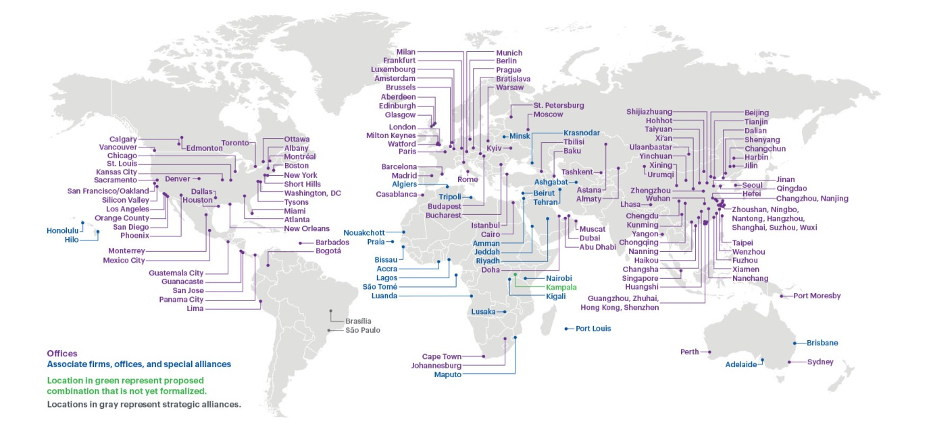

About Dentons
Dentons is the world's largest law firm*, delivering quality and value to clients around the globe. Dentons is a leader on the Acritas Global Elite Brand Index, a BTI Client Service 30 Award winner and recognized by prominent business and legal publications for its innovations in client service, including founding Nextlaw Labs and the Nextlaw Global Referral Network. Dentons' polycentric approach and world-class talent challenge the status quo to advance client interests in the communities in which we live and work. www.dentons.com

* The American Lawyer 2016 – Global 100 law firm ranking by number of lawyers.

