Rema’s most environmentally-sound grocery store in Norway was built using Ruukki life panels
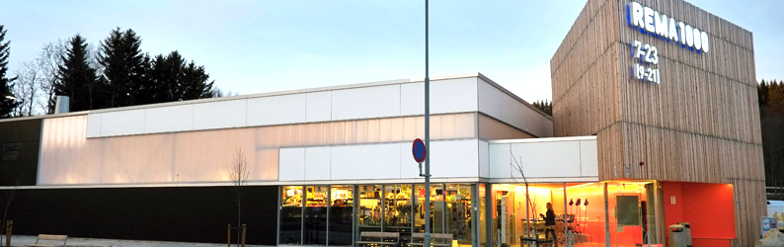
The Rema 1000 concept store in Kroppanmarka, Trondheim, Norway has used a wide range of energy-saving and environmentally-sound solutions. Ruukki’s energy-efficient life panels reduce the entire lifecycle environmental impacts of the building.
When it opened in mid-August 2013, the Rema 1000 store in Kroppanmarka in Trondheim was called the most environmentally-sound grocery store in Norway. Since energy use is one of the largest costs of running a store, the aim was to use the most energy-efficient solutions available. The building covers about 1,200 square metres and uses up to 30 per cent less energy compared to similar grocery stores of the same size.

Ruukki’s panels are airtight and insulate
The walls consist of sandwich panels from Ruukki complemented with wood panels. Fresvik Produkt was responsible for installing the façade.
“Ruukki’s panels were right for the grocery store walls. The panels have good insulation properties and make the building airtight and very energy efficient,” project manager Arek Lekki says. One of the main challenges for Fresvik Produkt was to install the wood panels on top of Ruukki’s sandwich panels. “We had to use special fittings in order to keep the building airtight,” adds Lekki.

Heat recovered from refrigeration
The refrigeration system is environmentally sound since it uses carbon dioxide as refrigerant and also serves as the building’s heat pump. The surplus heat from the refrigeration system is used to heat up the building in winter and provides cooling for the air-conditioning unit in summer. The surplus heat is used for underfloor heating and to heat the supply air of the ventilation unit. In addition, the surplus heat also keeps the pavements and the loading bays free of snow and ice in the winter. At the heart of the system are four geothermal wells at a depth of 170 metres. In summer, the building is cooled by pumping heat into the wells, which serve as a heat source to heat the building in winter.

Energy efficiency from roof to windows
The roof of the store is covered with sedum, a plant that has water-storing leaves. Capable of storing large amounts of rainwater, the sedum plants contribute to better insulation of the building. The store also uses less energy since the large windows allow more daylight in. The window panels are made of polycarbonate slabs filled with an insulating airgel. “It’s the first time this material has been used in Norway,” says Arek Lekki.

Contemporary functional architecture
The Kroppanmarka project is a concept store to be used as a blueprint when building new grocery stores in the Rema 1000 chain, which already has more than 500 stores in Norway. Apart from the energy-saving solutions and environmentally-aware approach, the company’s CEO, Ole Robert Reitan, says it was also important to build more visually attractive stores. The Norwegian architect firm Snøhetta was tasked with creating a contemporary, functional building that blends into its environment. The project was partly funded by Enova, a state-owned association. Many of the energy-saving solutions have been developed in cooperation with the independent research organisation Sintef.

Facts about the Rema 1000 store in Kroppanmarka
Commissioned by: Rema Eiendom Nord
Lead contractor: Hent
Architect: Snøhetta
Façade supplied by: Fresvik Produkt
Ruukki products: trusses, load-bearing roof profiles and 580 square metres of SPA200E Life panels

Ruukki life panels
Compared to traditional steel-faced sandwich panels, up to 85% less non-renewable raw materials and up to 40% less energy are used to manufacture Ruukki life panels. Also up to 45% less carbon dioxide emissions are created.
Ruukki life panels not only promote sustainability, but also feature state-of-the-art technical properties. The panels are also quick and easy to install. Use of Ruukki life panels can result in a building scoring higher LEED and BREEAM points. Once the building has reached the end of its lifecycle, the panels can be removed and re-used in another building. Thanks to their durability and fire resistance, the panels can be re-used in different applications.
Read more about Ruukki's Life-panel

