OOO Ponsse selected the Ponsse subsidiary of 2018
Ponsse Group’s Russian subsidiary OOO Ponsse was granted the Subsidiary of the Year 2018 award. The winner was chosen based on different key figures about business performance and overall positive development of operations.
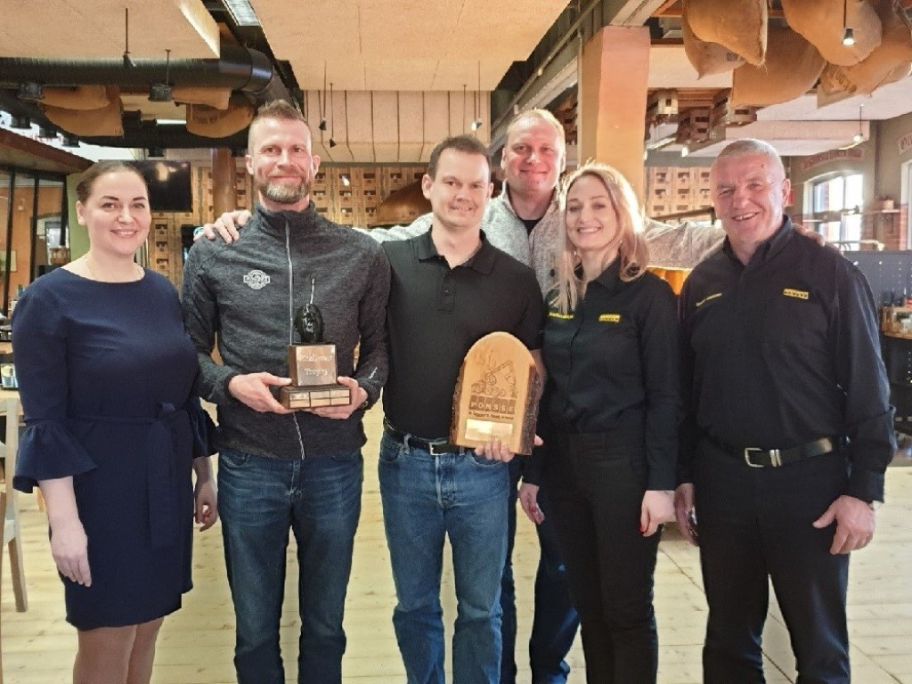
According to Ponsse Plc’s Sales and Marketing Director Jarmo Vidgrén OOO Ponsse has been able to develop all its functions while maintaining a good balance. “The company’s development in sales of new machines and harvester heads has been excellent. At the same time, the company has invested in the development of maintenance services and increased their net sales. This has only been possible by developing the network and investing not only in facilities, but also in the competence of the personnel. OOO Ponsse also sets a good example in supporting its local dealer network.”
In August, OOO Ponsse will open new training and service facilities in its current premises. “The significance of training and customer support is increasing, and OOO Ponsse has developed its training network in the long term”, Jarmo Vidgrén continues.
The Russian Ponsse subsidiary was founded in 2005, but the first PONSSE forest machines were exported to the country in the 1980s.

